**LAB # 04**

**OBJECTIVE**: To understand arrays and its memory allocation.

**LAB TASKS**

1. Write a program that takes two arrays of size 4 and swap the elements of those arrays.

**Code :**

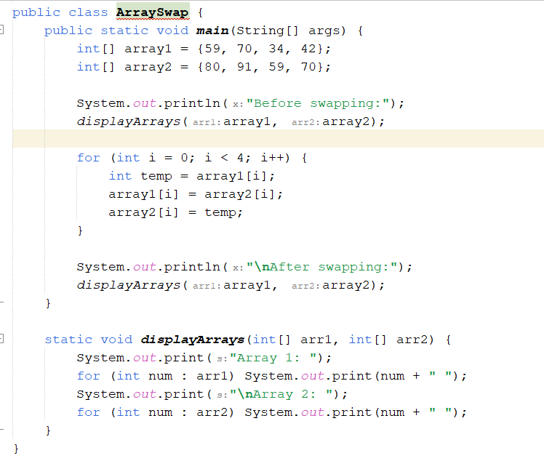

**Output :**

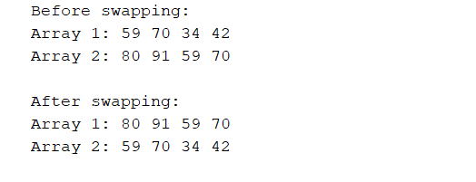

1. Add a method in the class that takes array and merge it with the existing one.

**Code :**

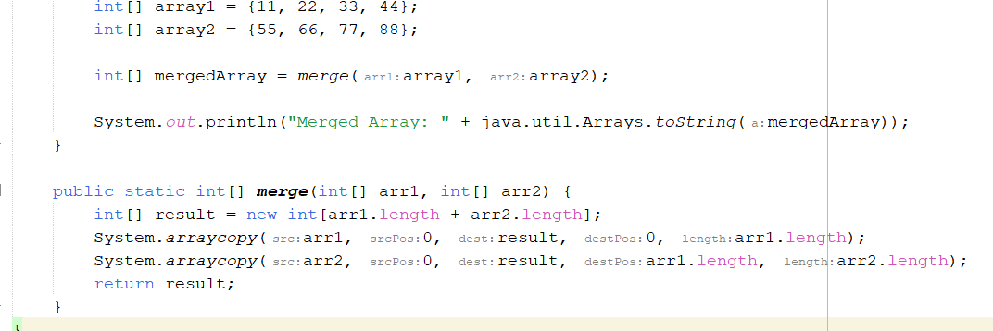

**Output:**



3. In a JAVA program, take an array of type string and then check whether the strings are palindrome or not.

**Code:**

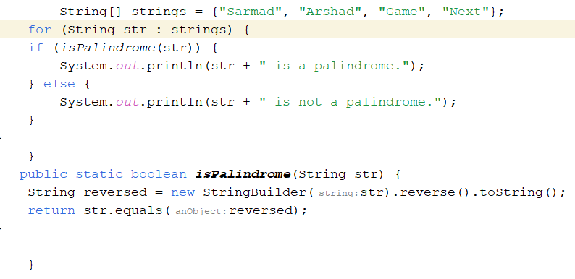

**Output :**

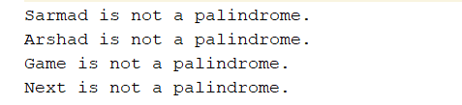

1. Given an array of integers, count how many numbers are even and how many are odd.

**Code :**

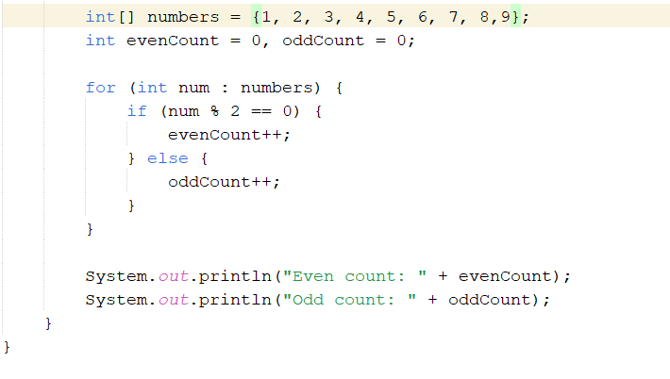

**Output :**



5.Given two integer arrays, merge them and remove any duplicate values from the resulting array.

**Code:**

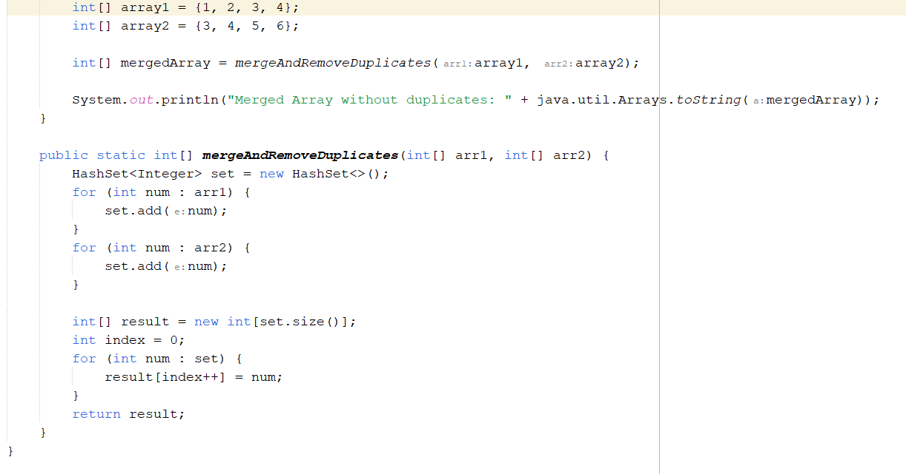

**Output:**



**HOME TASKS**

1.Write a program that takes an array of Real numbers having size 7 and calculate the sum and mean of all the elements. Also depict the memory management of this task.

**Code :**

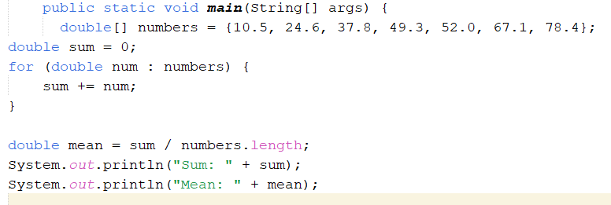

**Output :**

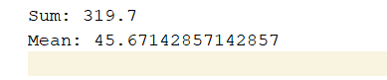

2.Add a method in the same class that splits the existing array into two. The method should search a key in array and if found splits the array from that index of the key.

**Code :**

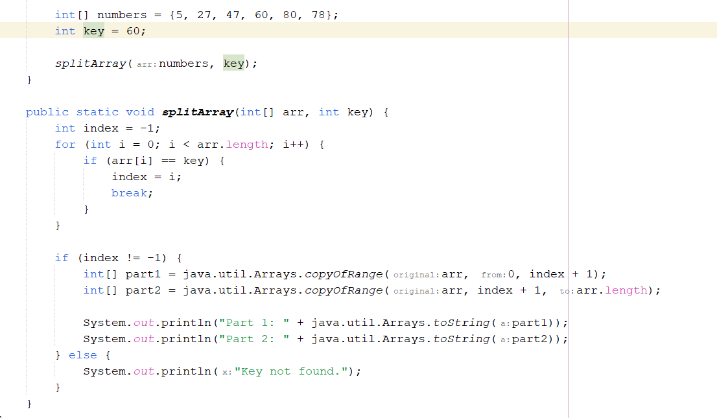

**Output:**

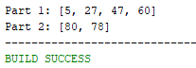

3.Given an array of distinct integers and a target integer, return all unique combinations of numbers that add up to the target. Each number can be used only once in the combination.

**Code:**

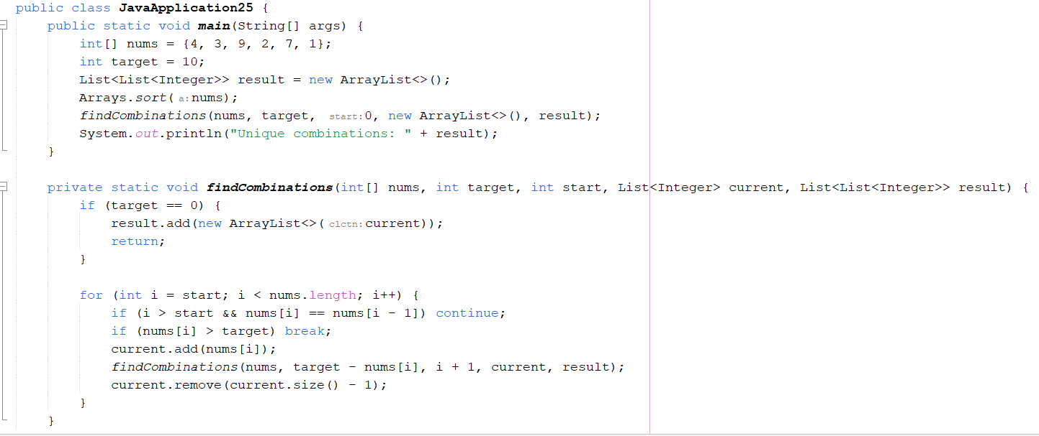

**Output:**



4.You are given an array containing n distinct numbers taken from 0, 1, 2, ..., n. Write a program to find the one number that is missing from the array.

**Code :**

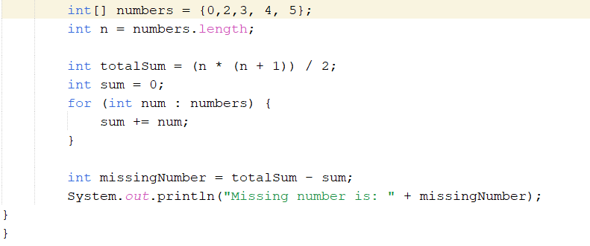

**Output :**



1. You are given an array of integers. Write a program to sort the array such that it follows a zigzag pattern: the first element is less than the second, the second is greater than the third, and so on.

**Code:**

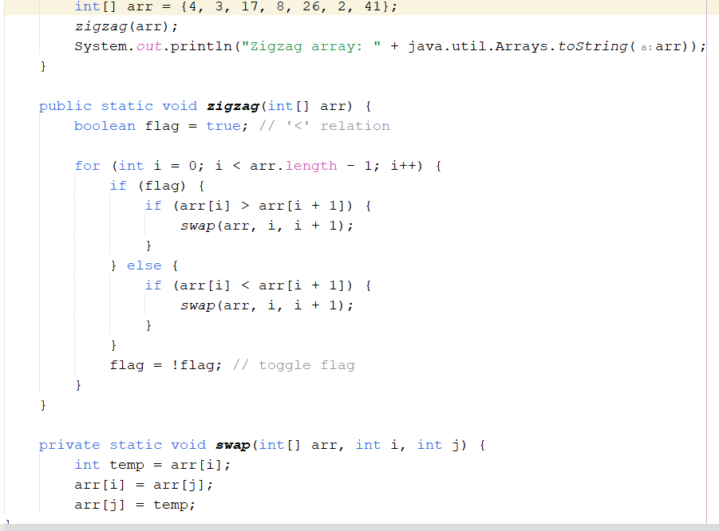

**Output:**

